MIM V4 — test case TC-03: investigate INC2684506 on kw3l1p714 (a server that sends no metrics)
Dashboard | MIM V4, Kibana 9.5.3
Objective | Show that an incident on a server that sends no metrics is still recognised as a server: Server Health shows it as "No data in window" instead of staying empty, and the other panels say who owns it and whether it is reachable
Why this incident | Round 19 picked it for TC-03: a production Windows Server with no metrics in Elastic
Result | Pass. Server Health listed KW3L1P714 as "No data in window". Its ping monitor was Down for all 1,440 checks: the server is unreachable
How the dashboard is read
The dashboard is read top to bottom, like an investigation:
- Section 1: what is open right now, across all incidents.
- Section 2: what the affected CI is, who owns it, and what it is connected to.
- Section 3: how its applications, services and server are doing.
The controls at the top decide what sections 2 and 3 show. Here the incident's CI is a server, so the server panels follow it directly. It sends no metrics, so the CMDB is what tells the dashboard it is a server.
Test flow
The path followed in this test, with what each step showed.
- Green: the step and its result.
- Amber: a decision.
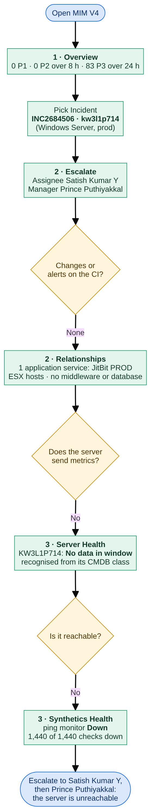
Inputs
Control | Value | Why
Incident | INC2684506 · kw3l1p714 | The incident under test; its affected CI is a Windows Server that sends no metrics
CI | (no CI selected) | Not needed: an incident's CI always wins
Server | (no server selected) | Not needed: the incident's CI is already a server
Application / Telemetry | (all applications) | Defaults
Service | (services on this CI) | Default: the APM services on the CI (none here)
Health window | 24 hours | How far back the health panels look

Step 1 — Major Incident Overview
What to show: the starting point for the MIM lead. Section 1 answers "how bad is it across the estate?" and does not change with the incident picked.
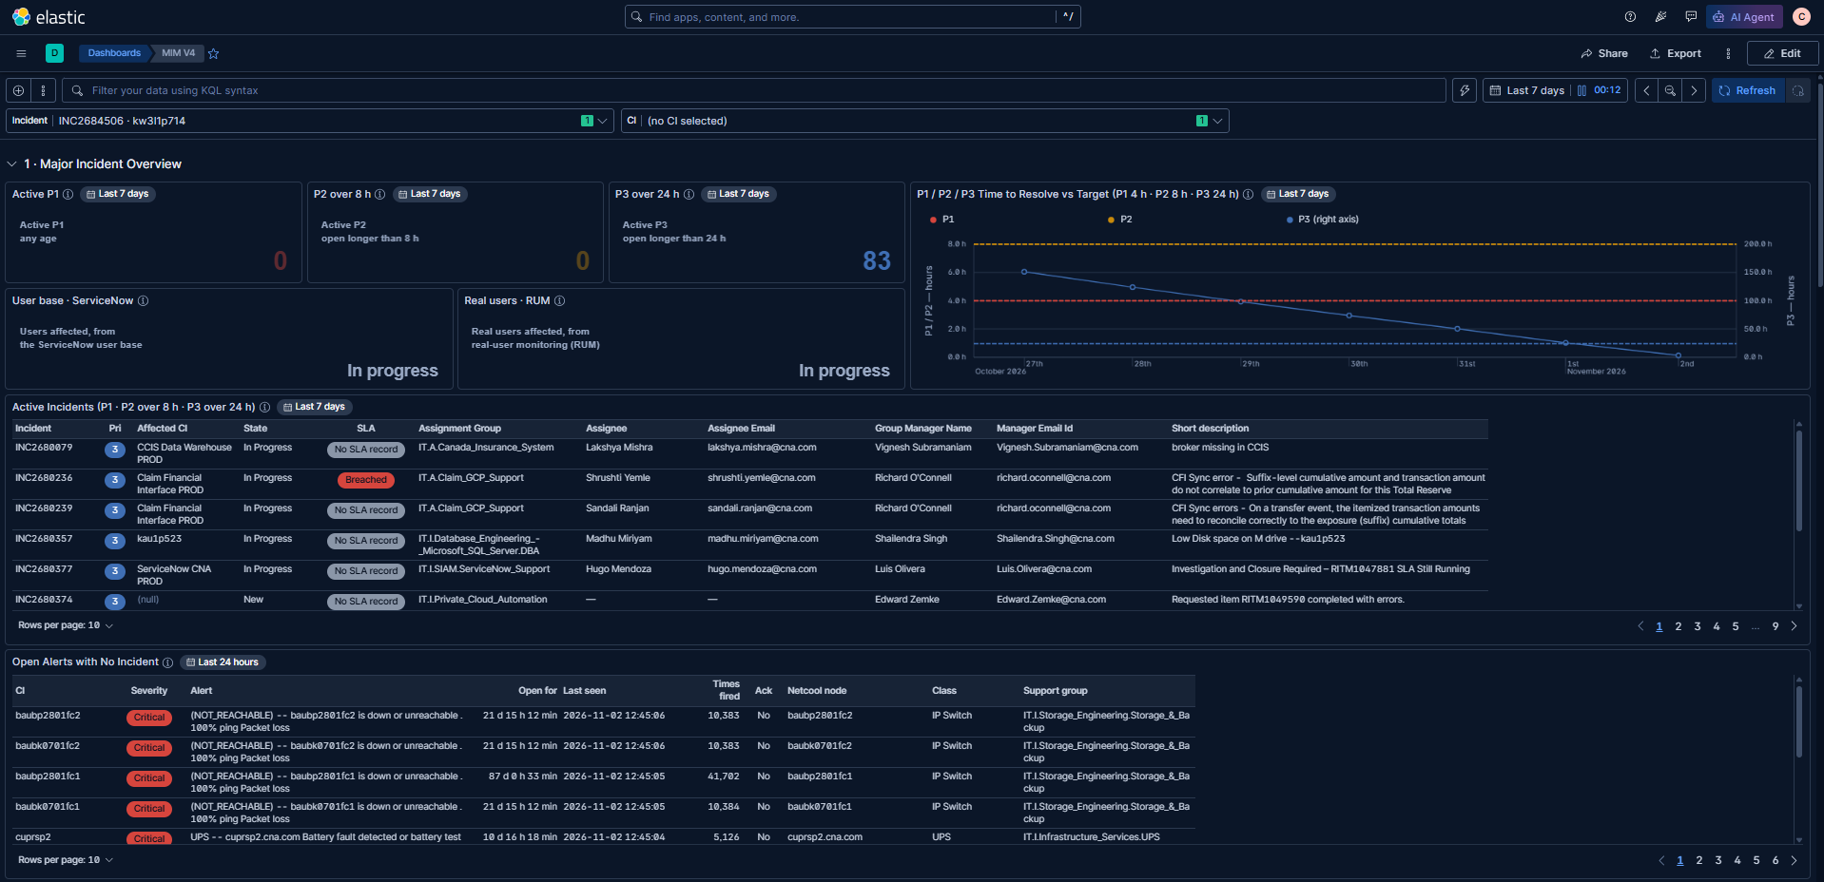
Check | Result
Incident control holds INC2684506 · kw3l1p714 | ✅
Active P1: 0 · P2 over 8 h: 0 · P3 over 24 h: 83 | ✅
Time to Resolve vs Target: P1 / P2 on the left axis, P3 on the right axis, dashed targets | ✅
Active Incidents: SLA column, e.g. INC2680236 Breached, the rest "No SLA record" | ✅
Users impacted: User base · ServiceNow and Real users · RUM, both "In progress" | ✅ placeholder
Open Alerts with No Incident: storage switches unreachable for 21–87 days, a UPS battery fault | ✅
Notes:
- INC2684506 is not in Active Incidents: it is On Hold, and section 1 leaves On Hold incidents out (TC-27). It can still be picked in the Incident control.
- P3 over 24 h is 83 here and 87 in TC-02, captured about 12 minutes apart: the count moves as incidents open, close and age.
Step 2 — Escalation, changes, alerts and relationships
What to show: who owns the server, whether anything changed or alerted on it, and what it is connected to.
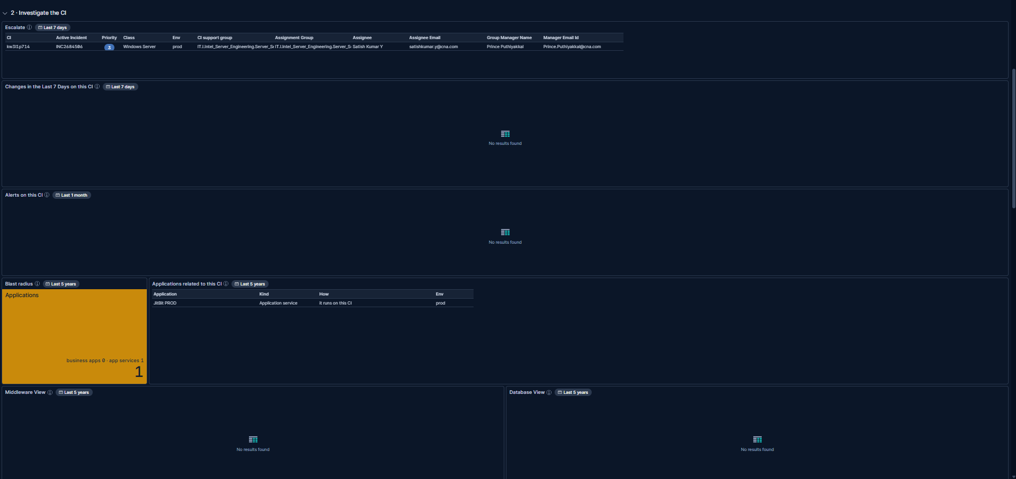
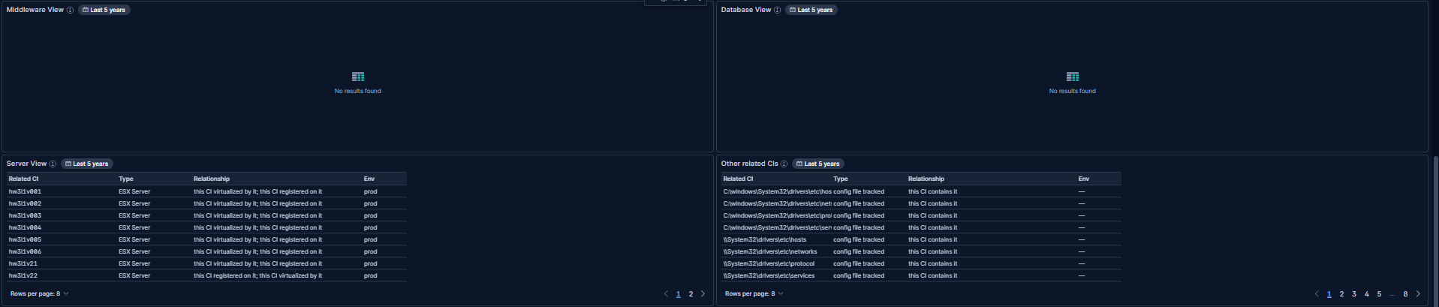
Check | Result
Escalate: kw3l1p714 · INC2684506 · P3 · Windows Server · prod; group IT.I.Intel_Server_Engineering.Server… (cut off in the table), assignee Satish Kumar Y, manager Prince Puthiyakkal | ✅
Changes in the Last 7 Days: empty | ✅ expected (no changes on this CI)
Alerts on this CI: empty | ✅ (no Netcool alert, although the server is unreachable; see step 3)
Blast radius: 1 (business apps 0 · app services 1) | ✅
Applications related to this CI: JitBit PROD (application service, runs on this CI) | ✅
Middleware View, Database View: empty | ✅ expected (none linked in the CMDB)
Server View: the ESX hosts it is virtualised by (hw3l1v001 … hw3l1v22; 2 pages) | ✅
Other related CIs: config files tracked on the server (8 pages) | ✅
Notes:
- Section 2 works without metrics: everything here comes from the incident and the CMDB.
- Blast radius 1: JitBit PROD runs on this server; that is the application to warn.
- No Netcool alert for a server that is down all day: worth raising with the monitoring team, since the ping monitor in step 3 sees it.
Step 3 — Server health for a server with no metrics
What to show: section 3 for a server that sends no metrics.
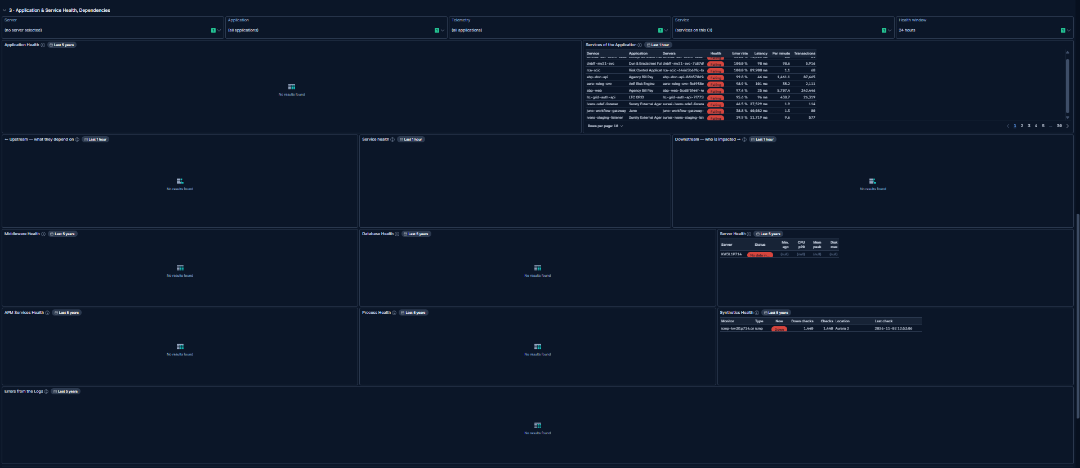
Check | Result
Server Health: KW3L1P714, status No data in window, every value null | ✅ the expected result for TC-03
Synthetics Health: ping monitor icmp-kw3l1p714 Down, 1,440 down checks out of 1,440, from Aurora 2, last check 2026-11-02 12:53 | ✅
Application Health, Upstream, Service health, Downstream, APM Services Health: empty | ✅ expected (no APM)
Middleware, Database, Process Health, Errors from the Logs: empty | ✅ expected (no data sent)
Services of the Application: every production service, worst first | ✅ expected (Application on (all applications))
Notes:
- "No data in window" is the point of TC-03: the server is recognised from its CMDB class, so it is listed, not silently missing. The name is in capitals because it comes from the CMDB record, not from a metrics document.
- Why there is no data: the ping monitor failed every check for 24 hours. The server is not just unmonitored; it is unreachable.

Outcome
- Pass: a server with no metrics is still shown. Server Health lists it as "No data in window" instead of staying empty, and section 2 fills from the CMDB.
- The server is unreachable: its ping monitor was Down for all 1,440 checks in 24 hours. That is the likely cause of the incident, and it affects JitBit PROD, which runs on it.
- No Netcool alert was raised for it: a monitoring gap to raise.
- Escalate to: Satish Kumar Y (assignee), then Prince Puthiyakkal (manager); both are named in Escalate.

